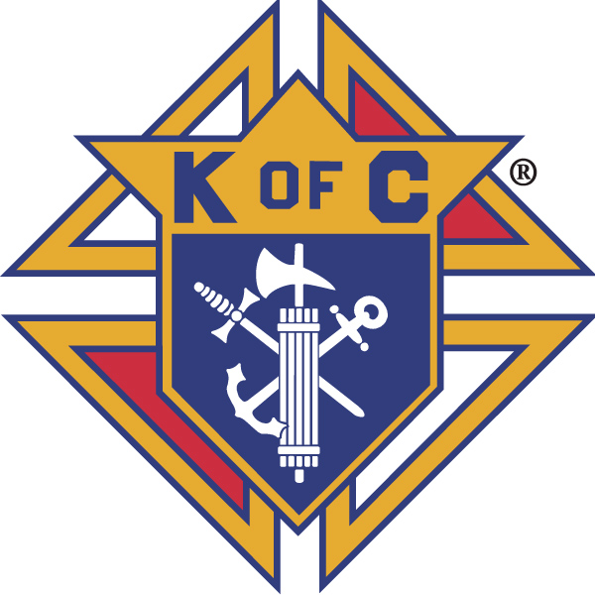 |  | Knights of Columbus  Ontario State Council  presents the
The Ontario State Council is pleased to announce that their 9th Annual True Fraternity “Swing into Spring” Golf Tournament will be held at WILLODELL GOLF CLUB OF NIAGARA on Thursday April 30, 2020.  This year’s tournament will take place the day before the start of our 117th Annual State Convention so we encourage Councils attending the Convention to come one day earlier to join Brother Knights and spouses from across the province to enjoy a fraternal day of spring golf in the Niagara Falls area.  The Ontario State Board looks forward to meeting everyone on the course as we open the 2020 golf season.  Our Convention hotel (Sheraton-on-the-Falls) will honor negotiated room rates 3 days prior and post-convention so that you may enjoy all the attractions that Niagara Falls has to offer.  For more information on the Golf Tournament or Sponsorship Opportunities please contact:  Golf Tournament Chairman  Joe Bodnar  905-242-3511 or by email: jandtbodnar@gmail.com  On-line Registration/Sponsorship form:  www.ontariokofc.ca  Package 1 $150.00 per person  Lunch  Power Cart and 18 holes of golf  Prime Rib Dinner  Package 2 $40.00 per person  Prime Rib Dinner (for guests of golfers)  $50.00 Income tax receipt available upon request for all golfers  Putting Contest (men and ladies)  Hole in One prize (one prize)  Closest to the Pin (men and ladies)  Longest Drive (Men and Ladies)  Best Score Prizes (foursome)  Grab Bags  50/50 Draw  Cash Bar |  | 9th Annual True Fraternity  “Swing into Spring” Charity Golf Tournament  (all proceeds go to fund the Martyrs’ Shrine Papal Altar and Lookout Tower refurbishment project)  Thursday April 30, 2020 – Willodell Golf Club of Niagara  10325 Willodell Rd. Niagara Falls www.willodellgolfclub.com  11:00 a.m. Putting Contest  12 pm Lunch 1 pm Shotgun Start  6:30 p.m. Prime Rib Awards Dinner (guests welcome to attend)  Registration Fee $150.00 per golfer  ($50.00 tax receipt available upon request)  Includes – Lunch, Golf, Power Cart, Dinner, Contests and Prizes  Dinner only option available for $40.00 (for non-golfers)  If you are not a golfer but want to attend the Prime Rib Dinner please purchase your Dinner Only ticket. All are welcome to come and cheer on the winners as they receive their prizes.  REGISTRATION DEADLINE: Friday April 24, 2020  PAYMENt Method - Make cheques payable to:  ONTARIO STATE COUNCIL KNIGHTS OF COLUMBUS  And please put “Fraternal Golf” in the memo line  Please mail completed registration form and cheque to:  Ontario State Office Knights of Columbus  393 Rymal Road West, Suite 201  Hamilton, Ontario L9B 1V2  Knights of Columbus Ontario State Board  9th Annual “True Fraternity” Swing into Spring  Charity Golf Tournament  Registration Form  Foursome (Council) or individual  Lunch - Power Cart & Golf-Prime - Rib Dinner  $150.00 per person  Golfer 1: Name…………………………….................  Address………………………………………………….  Phone #.....................................................................  Email……………………………………………………..  Council #..................................................................  Golfer 2: (name)……………………………………….  Golfer 3: (name)……………………………………….  Golfer 4: (name)……………………………………….  Prime Rib Dinner Only ($40.00 each)  Guest 1: (name)………………………………………  Guest 2: (name)………………………………………  Guest 3: (name)………………………………………  Guest 4: (name)………………………………………  PAYMENt Method  Make cheques payable to:  ONTARIO STATE COUNCIL KNIGHTS OF COLUMBUS  And please put “Fraternal Golf” in the memo line  Please mail completed Registration form and cheque to:  Ontario State Office Knights of Columbus  393 Rymal Road West, Suite 201  Hamilton, Ontario L9B 1V2

